(a)



We attached the “Auto” dataset.

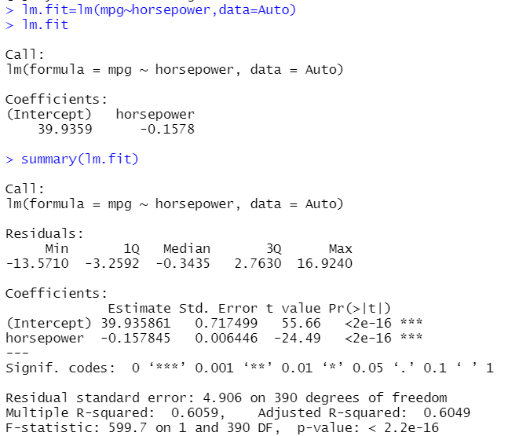

1. Since the p-value for the coefficient of horsepower is <0.05, we can conclude at 5% level that, there is a strong evidence of relationship between mpg and horsepower.
2. The R2 value is 0.61, which means, 61% of the total variation in the data can be explained by our fitted equation. So, the relationship between predictor and response is more or less strong.
3. Since, the slope coefficient is negative, so the relationship between predictor and response is negative. For 1 unit increase in horsepower, mpg decreases by -0.16 unit.

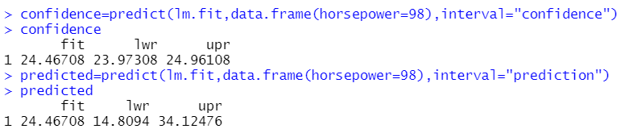

Predicted mpg associated with horsepower of 98 is 24.47.

Confidence interval for this predicted response is [23.97, 24.96]. If there is a number of samples, and for each sample, we wish to predict mpg for horsepower 98, then we can be 95% confident that the average mpg will fall in the interval stated above.

Prediction interval is [14.81, 34.12]. If, we wish to predict the mpg for horsepower 98, we can be 95% confident that, the true value of mpg for horsepower 98 will fall in that interval.

(b)



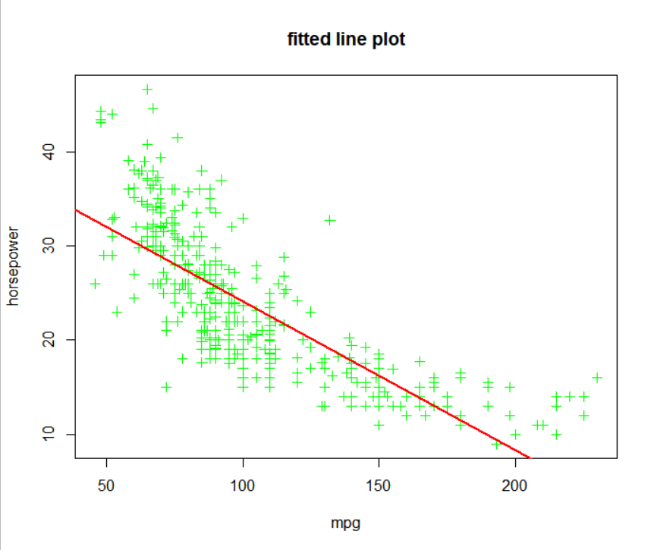

(c)



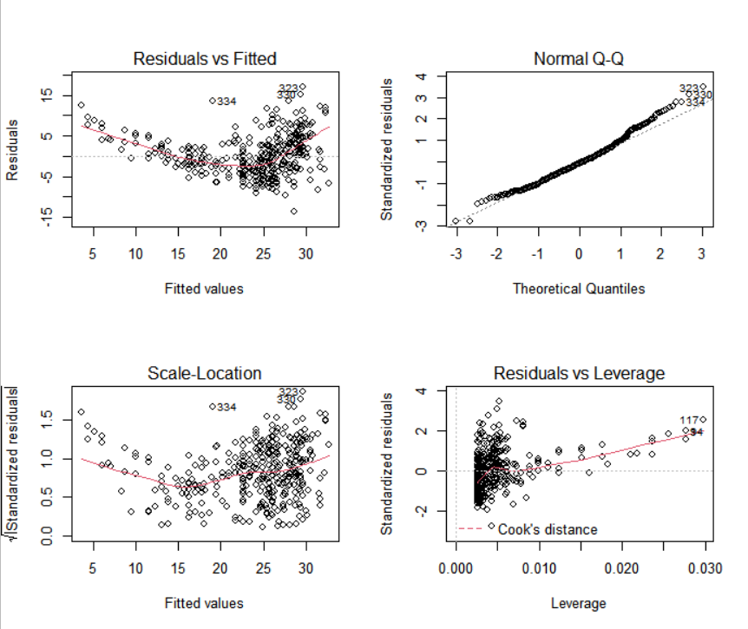

The residuals vs fitted plot shows U- shaped pattern, indicating presence of non-linearity in the data.

The residuals vs leverage plot shows that some observations have high leverage.

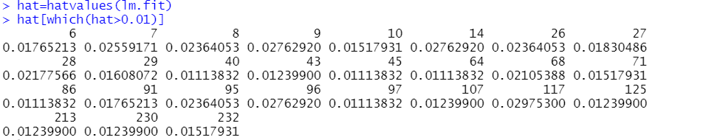

The scale-location chart shows some possible outliers. We can confirm by using studentized residuals  
to find observations with values greater than 3.

